Bug Report Template
Bug Report #1
Title
Videos cannot be played or paused.
Description
All Videos Fail to Load and displays error “Error Loading Video”
Severity
- Critical
Priority:
P1
Component
Video player
Environment
- Browser: Chrome
- OS: Windows 11
- Screen Size :1920x1080
- Device: Desktop
Preconditions: Application is running locally
Steps to Reproduce
- Open TinyFlix homepage
- Click on any video
- Observe the player behaviour and Wait for the video to load
Expected Behaviour
Videos should load and play without errors.
Actual Behaviour
All videos fail to load and show a generic error. An error message appears: “An error occurred while loading the video.”

Screenshots/Videos
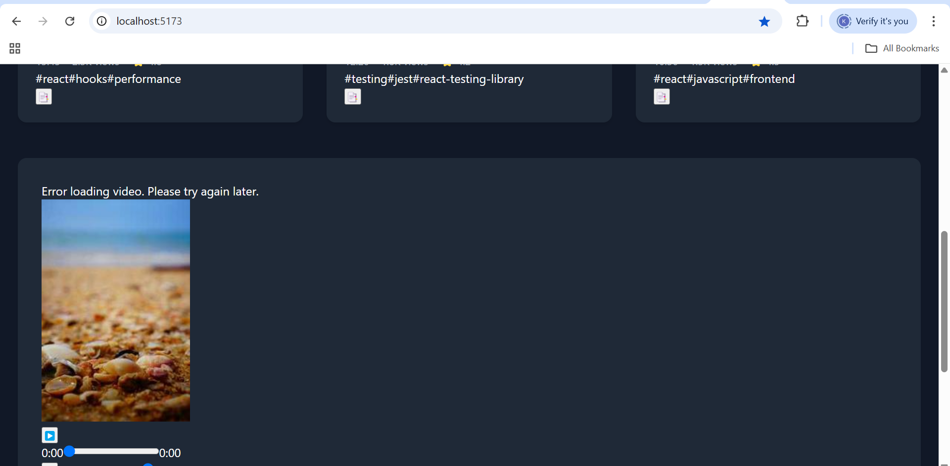
Additional context:
This issue occurs for every video, not just specific ones, indicating a global playback or source loading failure.
Suggested Fix
Check if video URLs in API are broken or inaccessible

Bug Report #2
Title
Sign-in flow is not functional.
Description:
When accessing the Tinyflix web application, there is no functional sign-in flow presented to the user. This prevents account-based actions like saving preferences, applying filters persistently, or uploading content.
Severity
- High
Priority
P1
Component
Authentication section
Environment
- Browser: Chrome
- OS: Windows 11
- Screen Size :1920x1080
- Device: Desktop
Steps to Reproduce
1.Go to the browser.
2. Look for sign-in button.
3.Click sign- in button
Expected Behaviour
A sign-in authentication flow should be functional, allowing users to log in.
Actual Behaviour
No sign-in flow is available on the page. Users remain anonymous, with no way to log in or save session data.
Screenshots/Videos
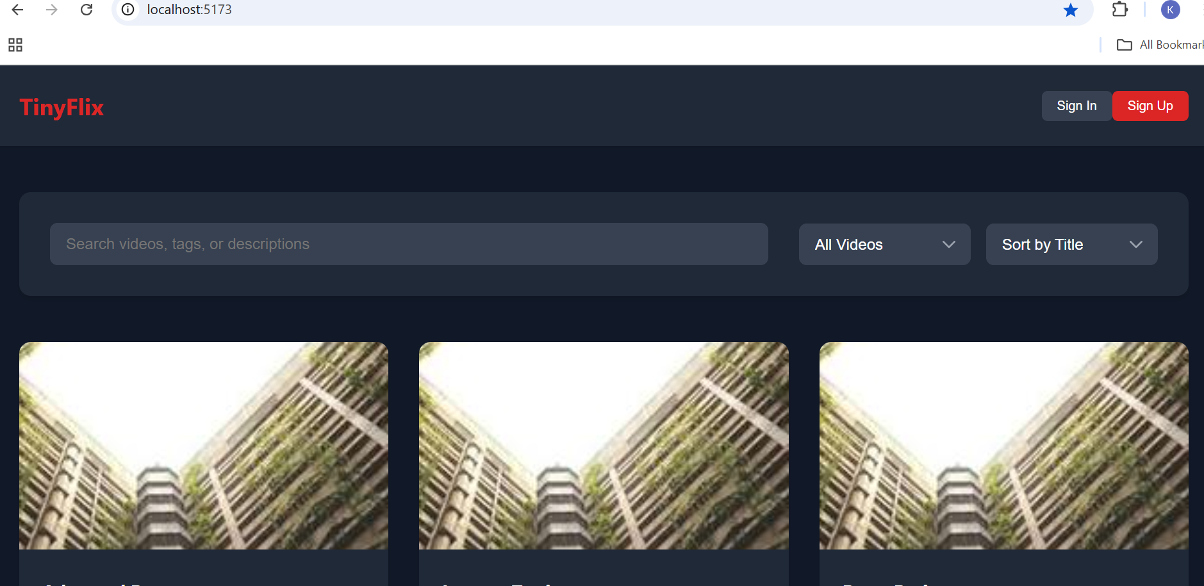

Suggested Fix
Implement or enable the existing auth flow

Bug Report #3
Title
Sign-up flow is not functional.
Description:
When accessing the Tinyflix web application, there is no sign-up flow presented to the user. This prevents account-based actions like saving preferences, applying filters persistently, or uploading content
Severity
- High
Priority
P1
Component
Authentication section
Environment
- Browser: Chrome
- OS: Windows 11
- Screen Size :1920x1080
- Device: Desktop
Steps to Reproduce
1.Go to the browser.
2. Look for sign-up button.
3.Click sign up button
Expected Behaviour
A sign-up flow should be visible and functional, allowing users to signup.
Actual Behaviour
No sign-up flow is available on the page. Users remain anonymous, with no way register.

Screenshots/Videos


Suggested Fix
Implement or enable the existing auth flow for sign up.

Bug Report #4
Title
“Recent" Filter Does Not Display Recently Added Videos
Description
The ‘Recent’ filter is intended to help users discover the most recently added videos on TinyFlix. However, when this filter is applied, the list does not reflect the newest content.
Severity
Medium
Priority
P2
Component
Sorting & Filtering
Environment
- Browser: Chrome
- OS: Windows 11
- Screen Size :1920x1080
- Device: Desktop
Steps to Reproduce
- Open TinyFlix homepage
- Use the dropdown to select the “Recent” filter
- Observe the list of videos displayed
Expected Behaviour
The most recently added videos should appear at the top
Actual Behaviour
The list does not change, or displays older/random videos
Screenshots/Videos
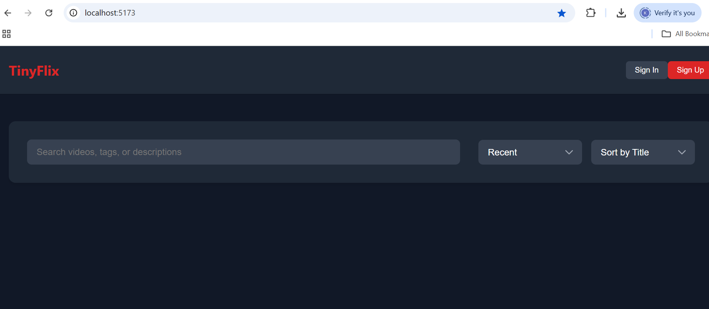
Additional Context
The "Recent" filter appears in the sorting dropdown, but selecting it does not visibly display videos.
Suggested Fix
Ensure filtering logic sorts videos by creation date descending.
Bug Report #5
Title
Like Button for Reply Comments Is Unresponsive
Description
In the comments section under videos, users can reply to other users' comments. Each reply comment includes a Like button that allows users to express appreciation. However, when users attempt to tap the Like button specifically for reply comments, nothing happens. The button does not register the tap — no animation, colour change, or count update — and no network activity is triggered.
This issue does not affect top-level comments, which respond as expected when liked.
Severity
- Medium
Priority
P2
Component
Comments Section
Environment
- Browser: Chrome
- OS: Windows 11
- Screen Size :1920x1080
- Device: Desktop
Steps to Reproduce
- Navigate to any video with existing comments and replies
- Locate a reply under a parent comment
- Click the "Like" button on the reply
Expected Behaviour
The like count should increment and the button should highlight or toggle state
Actual Behaviour
Nothing happens when the "Like" button on a reply comment is clicked
Screenshots/Videos
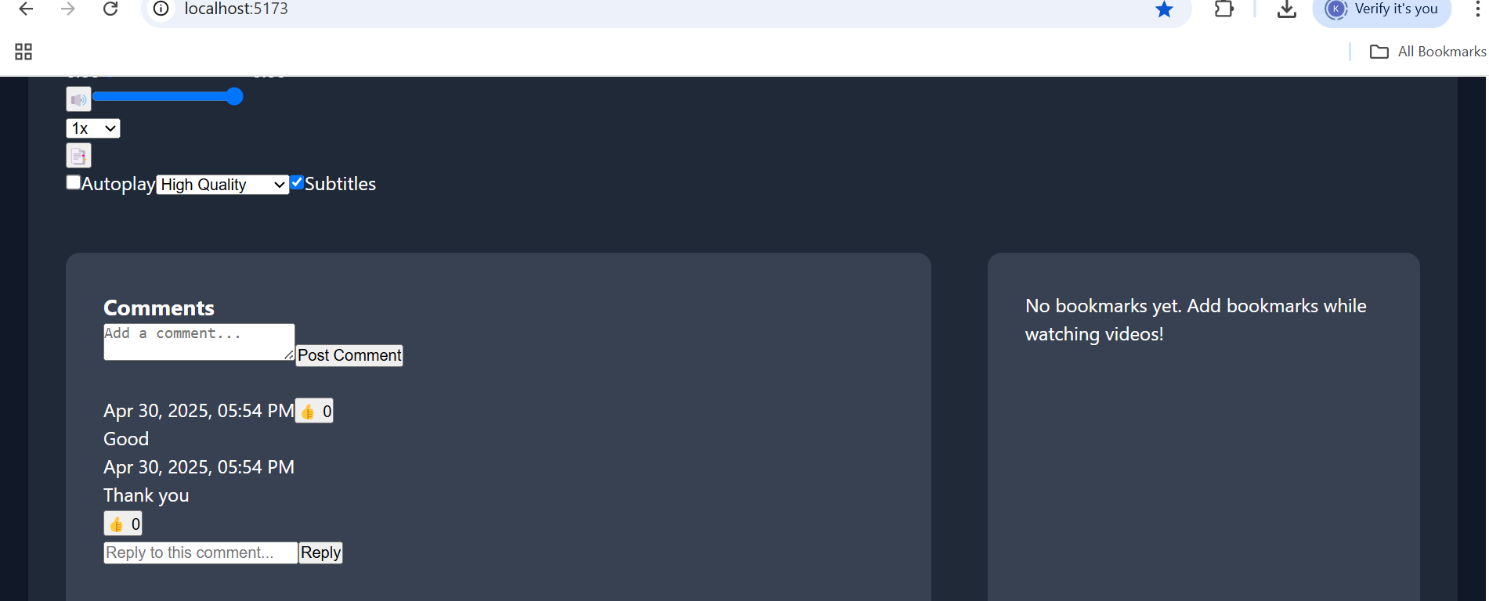Additional Context
This issue appears only for reply-level comments; liking parent comments works correctly.
Suggested Fix
Check if the reply comment object is correctly wired to the like API.

Bug Report #6
Title
Refresh resets ‘Sort by rating’ and ‘Sort by date’ filter and shows ‘Sort by title’ videos
Description
When clicking refresh it resets ‘Sort by rating’ and ‘Sort by date’ filters to default ‘Sort by title’
Severity
- Medium
Priority
P2
Component
Sorting and Filtering Section
Environment
- Browser: Chrome
- OS: Windows 11
- Screen Size :1920x1080
- Device: Desktop
Steps to Reproduce
1.Go to the video listing page.
2.Apply a filter based on rating or date
3.Observe the filtered results.
4.Refresh the page.

Expected Behaviour
The filter should persist after refresh, and only videos matching the selected rating should be displayed. The rating filter remains active after the page refresh, and only matching videos are shown.

Actual Behaviour
The filter is reset after the refresh, and the list of ‘Sort by title’ videos appears.
Screenshots/Videos
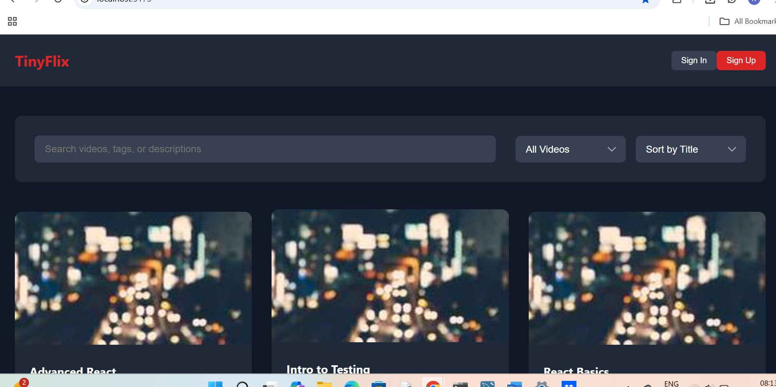

Suggested Fix
Maintain filter state in URL query parameters.

Bug Report #7
Title
Refresh resets ’Recent’ and ‘Popular’ filter and shows ‘All videos’ videos
Severity
- Medium
Priority
P2
Component
Filter Section
Environment
- Browser: Chrome
- OS: Windows 11
- Screen Size :1920x1080
- Device: Desktop
Steps to Reproduce
1.Go to the video listing page.
2.Apply a filter based on ‘Recent’ or ‘Popular’
3.Observe the filtered results.
4.Refresh the page.
Expected Behaviour
The filter should persist after refresh, and only videos matching the selected rating should be displayed. The rating filter remains active after the page refresh, and only matching videos are shown.
Actual Behaviour
The filter is reset after the refresh, and the list of ‘All videos’ videos appear.
Screenshots/Videos


Suggested Fix
Maintain filter state in URL query parameters.

Bug report#8
Title
Clicking Bookmarks Doesn’t Jump to Timestamp
Description
When a user clicks on a saved bookmark in the video player interface, the video does not seek to the associated timestamp. These breaks expected behaviour and reduces the usefulness of bookmarks as a navigation tool.
Severity
- Medium
Priority
P2
Component
Bookmarks section
Environment
- Browser: Chrome
- OS: Windows 11
- Screen Size :1920x1080
- Device: Desktop
Steps to Reproduce
- Play a video on Tinyflix.
- Create a bookmark at a specific timestamp (e.g., 01:05).
- Click on that bookmark in the list or sidebar.
- Observe that the video does not jump to the selected timestamp.
Expected Behaviour
Clicking on a bookmark should trigger the video player to seek to the corresponding time (e.g., video should jump to 01:05).
Actual Behaviour
Clicking the bookmark has no effect; the video continues playing from its current time.
Screenshots/Videos
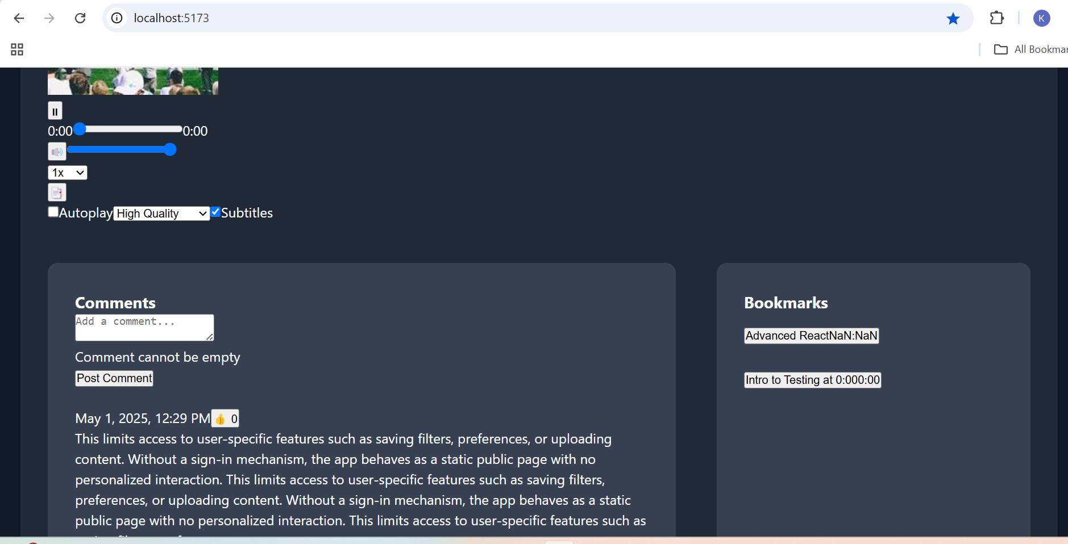

Bug report #9
Title
Broken thumbnails displayed for all videos when network disconnects in TinyFlix
Description
When network is disconnected, videos are displayed as broken thumbnails.
Severity
- Medium
Priority
P2
Component
Bookmarks section
Environment
- Browser: Chrome
- OS: Windows 11
- Screen Size :1920x1080
- Device: Desktop
Steps to Reproduce
- Launch TinyFlix.
- While thumbnails are still loading, disconnect the network
- Observe the video list section.
Expected Behaviour
- App should detect the network disconnection.
- If thumbnails fail to load due to loss of connectivity, show a default placeholder image.
- Optionally, show a small overlay icon indicating "offline" or allow a retry when the network is restored.
Actual Behaviour
Video thumbnails are replaced with broken image icons or empty spaces. No fallback image or user-friendly message is shown. UI looks incomplete and unresponsive in those areas.
Screenshots/Videos
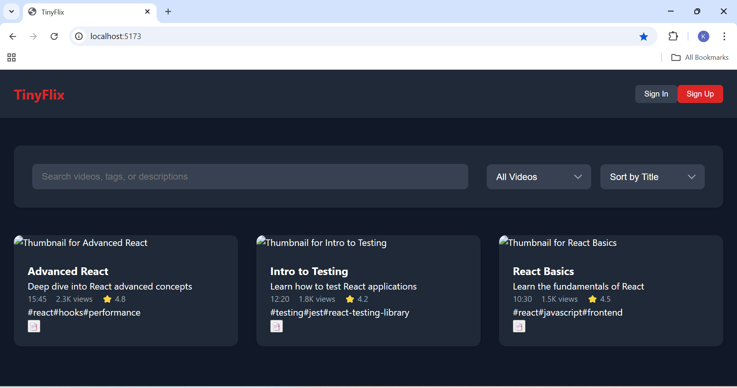

Bug Report #10
Title
No Warning Message When ‘Comment’ and’ Reply ‘Exceeds 500 Characters
Description
The comment input field and reply field allows users to enter more than 500 characters, but no warning or feedback message is displayed when the limit is exceeded. This may confuse users when their full comment is not saved or displayed correctly. If the input is more than 500 characters, it displays only the first 500 characters.
Severity
- Low
Priority
P3
Component
Comments section and reply section
Environment
- Browser: Chrome
- OS: Windows 11
- Screen Size :1920x1080
- Device: Desktop
Steps to Reproduce
  - Navigate to the comment input field.
  - Enter text longer than 500 characters.
  - Observe that no warning or character limit feedback is shown.
Expected Behaviour
A warning should appear once the character count exceeds 500, such as:
❗ Comment too long. Limit is 500 characters. (Current: 537)
Actual Behaviour
Users can type beyond 500 characters with no warning, potentially leading to confusion or data truncation.
Screenshots/Videos
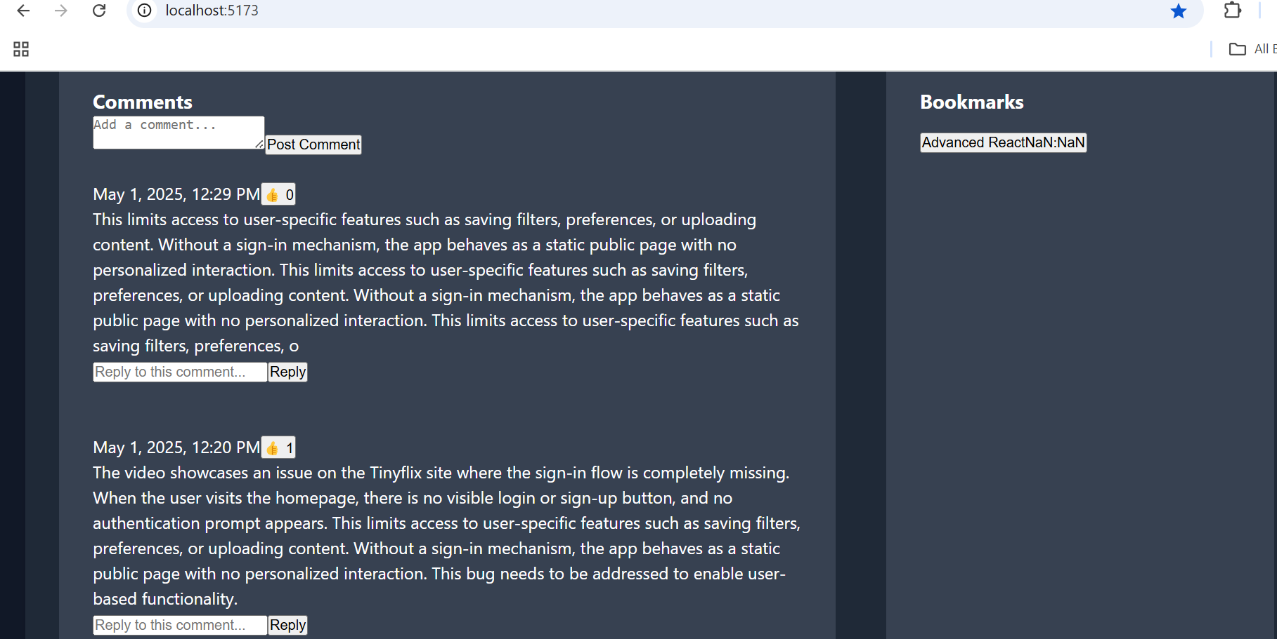

Suggested Fix
Display a real-time character counter below the input field (e.g., 432 / 500 characters).
Show a red warning message when the count exceeds 500.

Bug Prioritization
Critical Bugs
[Bug #1] - Videos cannot be played or paused.
High Priority Bugs
[Bug #2] - Sign-in flow is not functional.
[Bug #3] - Sign-up flow is not functional.
Medium Priority Bugs
[Bug #4] - “Recent" Filter Does Not Display Recently Added Videos
[Bug #5] - Like Button for Reply Comments Is Unresponsive
[Bug #6] - Refresh resets ‘Sort by rating’ and ‘Sort by date’ filter and shows ‘Sort by title’ videos
[Bug #7] -Refresh resets ’Recent’ and ‘Popular’ filter and shows ‘All videos’ videos
[Bug #8] - Clicking Bookmarks Doesn’t Jump to Timestamp
[Bug #9 - Broken thumbnails displayed for all videos when network disconnects in TinyFlix
Low Priority Bugs
[Bug #10] - No Warning Message When ‘Comment’ and’ Reply ‘Exceeds 500 Characters

Summary of Findings
Total Bugs Identified:10
Distribution by Severity
- Critical: 1
- High: 2
- Medium:6
- Low: 1
Distribution by Component
- Video Player: 1
- Search/Filter: 3
- Bookmarks: 1
- Comments: 2
- Performance: 1
- Other: 2
Recommendations
Immediate Actions
1. Fix Sort State Persistence on Refresh
- Ensure user-selected sort filters (e.g., rating, date) persist after refresh.
2. Resolve Broken Thumbnails on Network Disconnect
- Implement fallback thumbnails or placeholders.
- Show a “retry” icon or auto-retry logic when the network is restored.
3. Make Like Button Functional on Reply Comments
- Add missing tap/click event listeners for nested comment elements.
4. Correct ‘Recent’ Filter Logic
- Ensure newly added videos surface correctly at the top.
5. Improve Offline Handling
- Gracefully handle full/partial network disconnections.
- Add offline indicators where feasible.

Long-term Improvements
UI Feedback for Actions
- Add visual feedback (like animation or colour change) when a button is tapped, even before the backend confirms.

